Programming Fundamentals and Unit Testing
Regular Exam – 2 March 2025
Submit your zip file here: https://judge.softuni.org/Contests/5375/Programming-Fundamentals-and-Unit-Testing-Regular-Exam-2-March-2025

4. Unit Test List: Consonants Counter
Test a given method which takes in a list of strings and returns the total number of consonants found in the list. The program considers consonants to be 'b', 'c', 'd', 'f', 'g', 'h', 'j', 'k', 'l', 'm', 'n', 'p', 'q', 'r', 's', 't', 'v', 'w', 'x', 'y', 'z' (both uppercase and lowercase).
The method is found in the ConsonantsCounter.cs file:
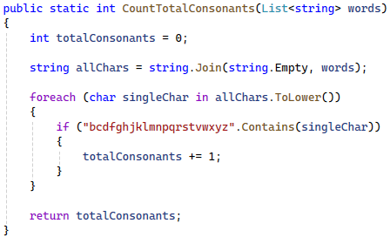
You are given a test file ConsonantsCounterTests.cs containing 5 empty tests. Implement all the unit tests:
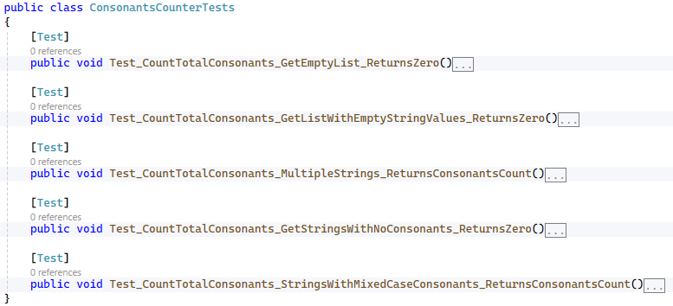
When you are ready make sure your tests run:
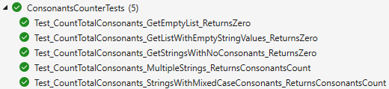
IMPORTANT: DO NOT REMOVE OR CHANGE ANY NAMESPACES AND USINGS.

